Internet and Web Programming

Lab Assignment 3

## Name: Om Ashish Mishra

## Registration Number: 16BCE0789

## Slot: E2

**i**) Create a page with JavaScript to do the following. These can all be on one page.

(a) Prompt the user for their name.

(b) Use a pop-up box to welcome the user by name.

(c) Display the current date on the page in the following format:

April 30, 2018.

Do not display the time.

(d) Display the last modified date of the document.

(e) Put some useful advice, on any subject, in the status line of the browser.

ii) Create a User Registration form with First Name, Last name, Address, City, State, Country, Pincode,

Username and Password fields for a General login webpage and satisfy the following criteria

***Create validate ( ) function for the following fields.***

(a) Checks that the First Name, Last Name, City, Country, Username, and Password1 fields are filled out.

(b) Checks that the Pincode is exactly 6 numeric’s.

(c) Checks that the state is exactly two characters.

(d) Checks that the email is a valid email address.

• false if email has fewer than 6 characters

• false if email does not contain an @ symbol

• false if email does not contain a period (.)

• true otherwise

# The Code:

<!DOCTYPE html>

<html>

<head>

<title>The Javascript in Use!!</title>

<style type="text/css">

body{

background-color: yellow;

border: 10px solid red;

padding: 10px;

}

</style>

</head>

<body>

<h1><center>The JavaScript is used !!</center></h1>

<p id="n"></p>

<script type="text/javascript">

function om(){

alert("Welcome to the page of Javascript Usage!!");

var x = window.prompt("Enter Your Name : ","Om Ashish Mishra");

if(x== null || x== "")

{

document.write("The name is missing!!");

}

else

{

document.write("Hi, "+x+" is my name.");

}

}

om();

function om1()

{

var d = new Date(Date.now());

var mn = ["January","Februray","March","April","May","June","July","August","September","October","November","December"];

var year = d.getFullYear();

var monthid = d.getMonth();

var month = mn[monthid];

var day = d.getDate();

if (day<10)

{

day = "0" + day;

}

document.write("<br>"+month+" "+day+", "+year);

}

om1();

function om2()

{

var x = new Date(document.lastModified);

document.getElementById('n').innerHTML = "Last Modified Date is : "+x;

}

om2();

function om3(input){

window.status = input;

document.write("<br>"+window.status);

return true;

}

var txt = "Good King Never Dies!!";

om3(txt);

function validate(){

//alert("I'm here")

var pincode1=document.getElementById("pin").value;

var state1=document.getElementById("s").value;

var email1=document.getElementById("E").value;

if(pincode1.length!=6){

var str="Invalid Pincode"

}

else{

//var str="Valid Pincode"

}

document.getElementById("pin").innerHTML=str;

if(state1.length!=2){

var str="Invalid State"

}

else{

//var str="Valid State"

}

document.getElementById("s").innerHTML=str;

if(email1.indexOf("@")<0 || email1.indexOf(".")<0 || email1.length<6){

var str="Invalid Email";

}

else{

//var str="Valid Email";

}

document.getElementById("E").innerHTML=str;

}

</script>

<br><br>

<form action="one.html" method="GET">

<div>

<label for="1st">First Name:</label><input type="text" name="first name" placeholder="John" id="1st" required="true">

<label for="2nd">Last Name:</label><input type="text" name="first name" placeholder="Smith" id="2nd" required="true">

</div>

<div>

<label for="ad">Address:</label>

<br>

<textarea name="address" placeholder="Write Your address here!!" id="ad" required="true" style="margin: 0px; width: 492px; height: 51px;"></textarea>

<br>

<label for="c">City:</label><input type="text" name="city" placeholder="Kolkata" id="c" required="true">

<label for="c">State:</label><input type="text" name="state" placeholder="WB" id="s" required="true" pattern="[A-Z a-z]{2}" size="2">

<label for="co">Country:</label><input type="text" name="country" placeholder="India" id="co" required="true">

<label for="co">Pincode:</label><input type="text" name="pincode" placeholder="700075" id="pin" required="true" pattern="(?=.*[0-9]).{6}" size="6">

</div>

<div>

<label for="us">Username:</label><input type="text" name="first name" placeholder="JS100" id="us" required="true">

</div>

<div>

<label for="m">Male </label><input type="radio" name="Gender" id="m" value="MALE">

<label for="f">Female </label><input type="radio" name="Gender" id="f" value="FEMALE">

<label for="o">Other </label><input type="radio" name="Gender" id="o" value="OTHERS">

</div>

<div>

<label for="E">Email: </label><input type="email" name="email" id="E" placeholder="your email" required="true" pattern="[a-z0-9._%+-].{6,}+@[a-z0-9.-]+.+[a-z]{2,3}$" >

<label for="P">Password: </label><input type="password" name="password" id="P" placeholder="your password" required="true" pattern=".{5,10}"" title="Password must be between 5 and 10 charaters">

</div>

<div>

<label for="A">I agree tp the terms and conditions </label><input type="checkbox" id="A" required="true">

</div>

<input type="submit" name="submit" onclick="validate()">

<br>

</form>

<hr>

<h1> Om Ashish Mishra - 16BCE0789 </h1>

</body>

</html>

# The Output:

The Alert Of Welcome

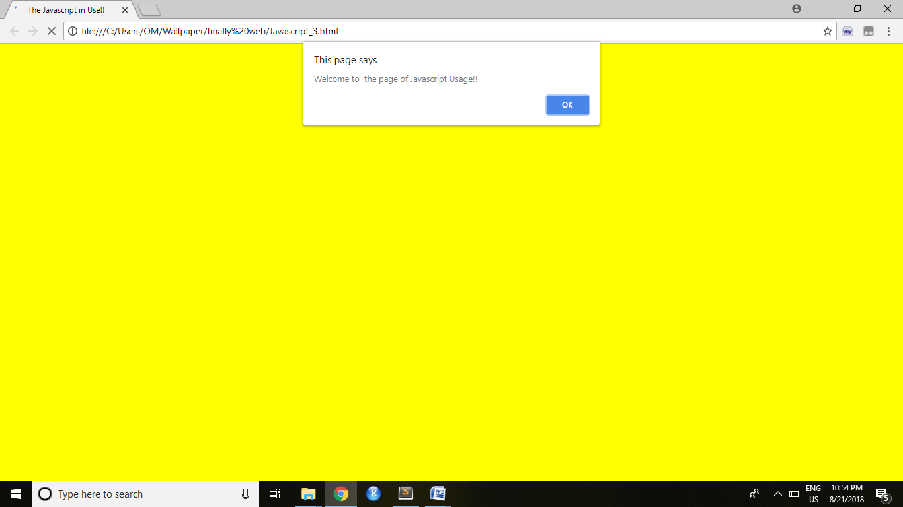



On Pressing “OK”

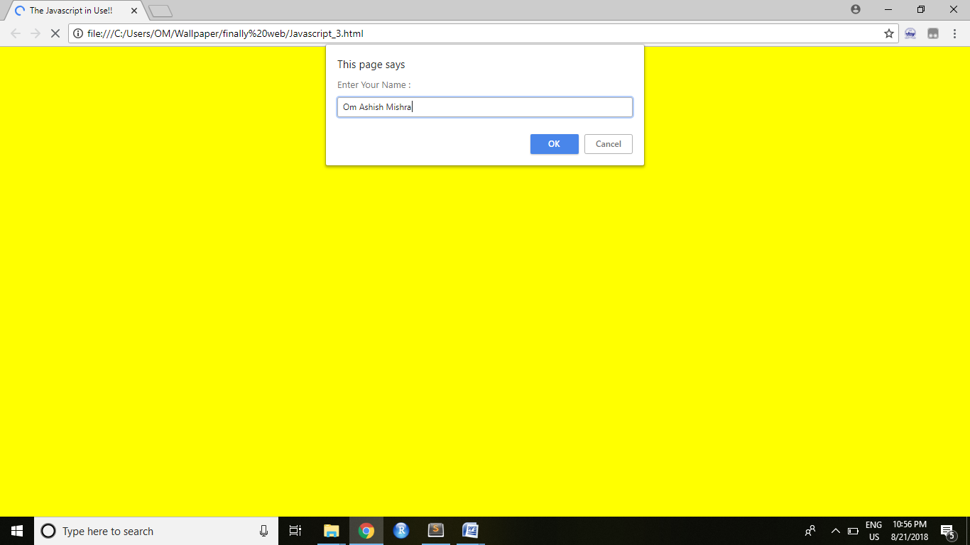



After Entering Name:

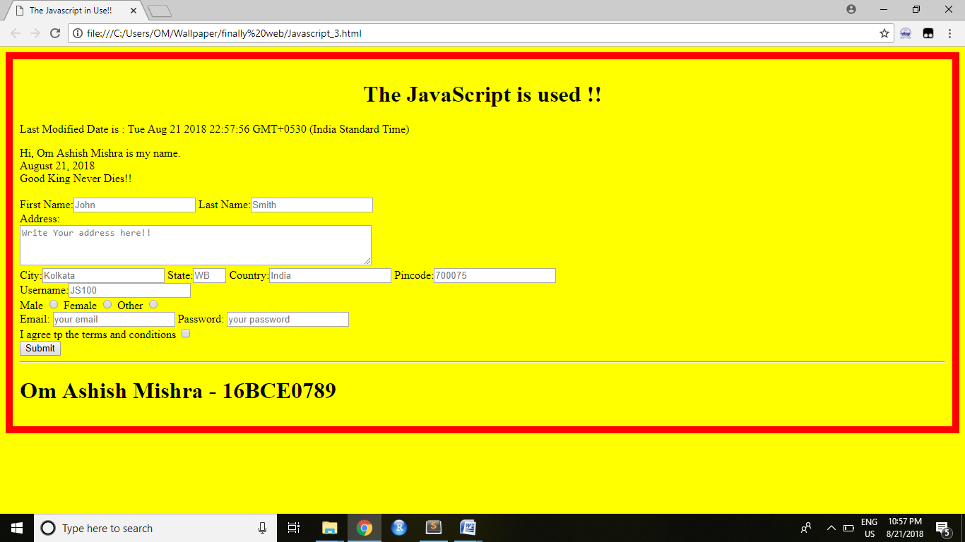

Modified Date



Name Display through Prompt:



The date shown:



The quote that should appear on status bar:



The Form with of Validation Done:

